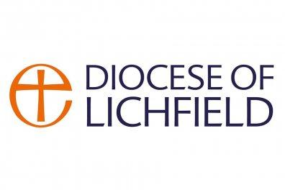

**All Saints Parish Church, Streetly**

**YOUTH MINISTER – ADVERT**

**37 Hours per week, worked flexibly** *with the possibility of a job share.*

**£24,000 per year and 28 days annual leave**

**Based at All Saints Church**

*with an expectation to work flexibly in other locations in Streetly, with the possibility of some remote/ home-based working.*

The mission of All Saints Church is connecting people to God and to one another. This new and exciting leadership post focuses on strengthening connections between the church and young people in Streetly. The role will involve nurturing current and initiating fresh opportunities to minister to 11–16-year-olds.

This is an opportunity for a Christian with leadership skills and experience of working with children and young people, to pursue a fresh vision for youth ministry in our community. This is a spiritual leadership role for someone who understands and models Christian commitment and values.

All Saints is a Parish Church, offering a wide variety of worshipping styles, open, and welcoming all, with excellent facilities and resources to support this ministry. You will work collaboratively with the ministry team (which includes a 0.5WTE Families and Children’s Worker in post, full time incumbent and Lay Readers and Church Wardens’ Team) supporting Sunday services and events providing teaching and outreach that engages children and young people. You will be supported by the PCC and wider community to strengthen existing ministry, extend, and develop new and innovative activities that will enable wider engagement with the local community and provide opportunities for young people to explore and deepen their faith.

If you are interested in exploring this post, we would love to hear from you. Please contact Revd Mandy Walker, Vicar All Saints,’ Streetly [revdmandywalker@btinternet.com](mailto:revdmandywalker@btinternet.com)

mobile: 07811 326204

Applications form from [allsaintstreetly@btinternet.com](mailto:allsaintstreetly@btinternet.com)

Closing date for interest and completed applications is Friday 31 October 2025

Interview week commencing 17 November 2025