Curate’s visit to South East Asia
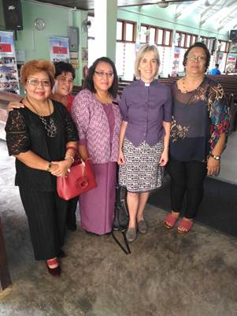

Revd Ana Lawrence, with her husband Kevin, travelled to the Dioceses’ of Kuching and Sabah in early 2019. Ana was, at the time, curate in the Benefice of Albrighton, Donington and Boningale.

What does the Church (in England) think of us? This question, put to us by a group of young adult Anglicans in Borneo recently, pulled us up short.
We were spending three wonderful weeks as guests of the Dioceses’ of Sabah and Kuching, Malaysia, as part of Ana’s curacy training; fulfilling a long held desire to travel to Malaysia, first prompted when a team from Sabah churches came to our church twenty five years ago.
If we were honest, we were not immediately sure how to answer that question from the young adults on behalf of you all!
The Anglican churches in Borneo contain an incredible diversity of language, culture and tradition. There may be Sunday services and cell groups in up to five different languages in a single parish in any one week.
And it was all on an eye opening scale! Worshipping in St Patrick’s Church, Tawau alongside 1,200 others on Chinese New Year was a profound and exciting time, whilst being invited to preach in a ‘smaller’ church outside Kuching meant speaking to 700, including an overflow of 300 in a neighbouring hall. The churches clearly placed a strong emphasis on discipleship, with highlights of our trip including sharing with mid-week cell groups and a Confirmation service, when the candidates alone nearly filled the church building.
Wherever we went, we were given an extravagant and heartfelt welcome, with the sharing of delicious local food, an essential part of any visit.
Of course, the churches in Borneo are facing their own issues. Malaysia is a majority Muslim country and the Christian church faces restrictions and pressures from government. Both Diocese’ also have a chronic shortage of ordained ministers and we were quizzed about finding good discipleship material for church members, particularly for those recently confirmed.
English missionaries founded the church in Borneo some 150 years ago and their legacy is remembered with gratitude and with a strong desire to build on that history. Both Dioceses’ were keen to continue to develop and continue informal, parish based links so please speak to me or contact Philp Swan, the Director of World Mission, if that is something you would be interested in pursuing. There is also a particular need for teachers for a church run international school and we can provide more details.
So back to that tricky question with which this article began. We would like to warmly encourage others to go to visit the churches in Malaysia and answer it for yourselves, warm sunshine and great food are just added bonuses!

Revd Ana Lawrence, with her husband Kevin, travelled to the Dioceses’ of Kuching and Sabah in early 2019. Ana is curate in the Benefice of Albrighton, Donington and Boningale.

