Curates’ visit to Qu’Appelle
The purpose of this placement was to provide the three second year curates from Lichfield Diocese with opportunities to learn about the Anglican Church in a different cultural setting. This builds on the long standing relationship between the Dioceses of Lichfield and Qu’Appelle and the exchange visits which have previously taken place which means that there is already an existing basis of friendship, trust and goodwill. For Revd Romita Shrisunder this was her first visit to one of the Companion Dioceses since her appointment as Bishop’s Director of Ordinands and she was able to gain insights into issues around vocation and the Vocational Diaconate. For Revd Philip Swan, the Diocesan Director of World Mission, it provided an opportunity to oversee and coordinate the overall programme and to learn from the experience in Qu’Appelle Diocese of Intentional Interim Ministry, since he now exercises a 50% Interim Ministry Role within Lichfield Diocese.
The programme was coordinated from Qu’Appelle by Archdeacon Catherine Harper. The first ten days were Regina based and we stayed at Kisik Towers in accommodation belonging to the University of Regina. Catherine organised the initial orientation session at Synod Office and the subsequent programme included a Post Ordination Training session, the Cathedral Lunch initiative, worship at a number of the Regina churches, input about the history of Qu’Appelle Diocese, meeting ecumenical partners, encountering the Indigenous Christian Fellowship, visiting churches and meeting church members from Fort Qu’Appelle and Lumsden, worshipping at St Luke’s on Gordon’s First Nation Reserve, spending some days at Moose Jaw, gaining insights from St Aidan’s and further input concerning the relationship with Indigenous People as well as meeting a former St Chad’s Volunteer.
The three curates, Jassica, Drew and Malcolm, then went on to Maple Creek with time at the Cowboy Church and participating in a book group. They then took part in a conference at Swift Current entitled ‘Who is my Neighbour?’, described as an educational conference to help foster understanding between the Church and Indigenous peoples featuring the Bishop of Saskatoon, the Rt Revd Christopher who is an Indigenous Bishop. The curates then finished their programme by participating in the Inter- Diocesan Retreat at Queen’s House Retreat Centre in Saskatoon.
For the purposes of this report we are including a number of selected extracts from the blog which was kept by the team which have an immediacy and freshness to them.

Revd Malcolm Mycock writes:
The first thing I do when I travel to somewhere new is find the location of the nearest AA (Alcoholics Anonymous) meeting. As a recovered alcoholic I count myself lucky; wherever I find myself I always have the ability to connect and meet up with people I know will accept me, understand me and who are willing to listen to things I am struggling with. The thing I find the most refreshing and freeing and helpful in AA is the honesty of the members, we share are highs and lows and our weakness, AA is a place you can be vulnerable without fear of judgement, you are accepted and loved for who you are, and through this healing happens. I think the church can learn a lot from AA.

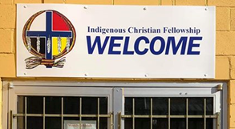
I was excited to find myself at the ‘Indigenous Christian Fellowship’ (ICF) in downtown Regina and to take part in the prayer gathering.
We read scripture which was linked to one of the 12 Steps of AA. In AA you are taken through the 12 steps, the steps help you to see your need for God, through a process of self-examination, and you are given steps, guidance on how to live life with God as your new manager. It was wonderful to see a Church embracing the 12 steps.

I would describe ICF as community, a 7 day church, with community breakfasts (a full breakfast for $1, that’s 60p), recovery meetings, there was a workshop on the Saturday for young people led by First Nation people, teaching the children a little of the Cree language and also making traditional First Nation bread ‘Bannock’, a church service on Sunday and so much more. The lady I sat next to at the prayer gathering told me how she came to the ICF every day, and she wasn’t the only one. When I think of the church I would love to be part of, it is church which I experienced at the ICF, a place people are drawn to and are accepted and loved, no matter what they look like or believe, they are loved unconditionally. I believe Jesus called us, called his church to be what I experienced here.’

Revd Romita Shrisunder writes:
‘We were shortly joined by some clergy of the diocese for lunch. Lunch was not just a feast but a manifestation of welcome, solidarity and friendship. After food, fun and fellowship we were kindly driven to the Ecumenical Partnership Meeting at the Roman Catholic Diocesan House. Although they had important agenda items to discuss they made us feel extremely welcome.

The meeting focused on the Covenant between the Anglican Church, Roman Catholic Church, Evangelical Lutheran Church and the Ukrainian Catholic Church. We were all encouraged to see the commitment of not only the people and but also the Bishops of the four Churches. We learnt about how the covenant is lived out in churches across the diocese and the blessings and challenges it brings and we also learnt about Anglican and Roman Catholic dialogues at national and international levels. We also had the opportunity to share how covenants and partnerships are lived out in our parishes in England.
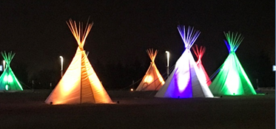
Our day ended with a surprise visit to the Royal Saskatchewan Museum. We were awestruck by the First Nations exhibit which offered a remarkable experience of the history of Aboriginal societies that live in Saskatchewan. I found this displayed at the exhibit which I thought is very apt as the diocese of Lichfield is urging churches to tackle climate change with a renewed understanding and focus: “Each society has its own way of understanding the world and humanity’s place in it. Traditional Indian cultures view human beings as one-among-many creations. All created beings have a spiritual presence and meaning. Humans must work with the earth, plants, and animals for mutual survival. The spirituality of the earth and all that it offered must be respected. Abuse of these resources leads to hardships for all”.

Revd Drew Walker writes:
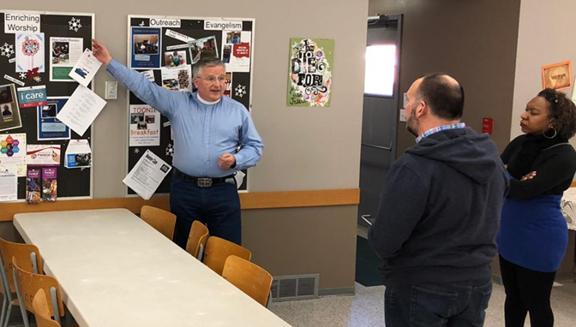
‘After a business of the cities today we headed out to Maple Creek, again just a short 3.5 hour drive. You get used to planning your journey by time in Canada. We were told by one lady ‘it’s not unusual for us to drive 2 hours for good tachos’. To try and understand its size the province of Saskatchewan can fit the UK in it 19 times over, and that’s just one province! The pace of life slowed down considerably for us, after a freshen up our host Venerable Peter Boote, archdeacon of the western Archdeaconry of St Chad, took us up to Cyprus Hills, a beautiful provincial park. We walked and talked about ministry here, we learnt about the differences between city and rural life; Maple Creek only has 2500 people in it. Peter took us around their camp area, where we sat amongst the snow in their outdoor chapel, this was a very special sacred space and one of great peace.

The next morning was book club, learning and sharing ideas from Paul Nixon’s ‘I’m not leading a dying church’ book. The ideas coming from the group gave us all such hope and encouragement. We then attended the ‘cowboy church’; for their equivalent to our lent lunch called 15 Golden minutes’ each year a different place of worship hosts a simple soup n sandwich lunch throughout lent and every week one of the churches presents a word from the Bible. We had some amazing conversations with folk’.

Revd Jassica Castillo-Burley writes:
As we travelled along the main highway, where all that we could see is dry land we listened to this song:
‘All this pain, I wonder if I'll ever find my way, I wonder if my life could really change, at all. All this earth, Could all that is lost ever be found?
Could a garden come out from this ground, at all?
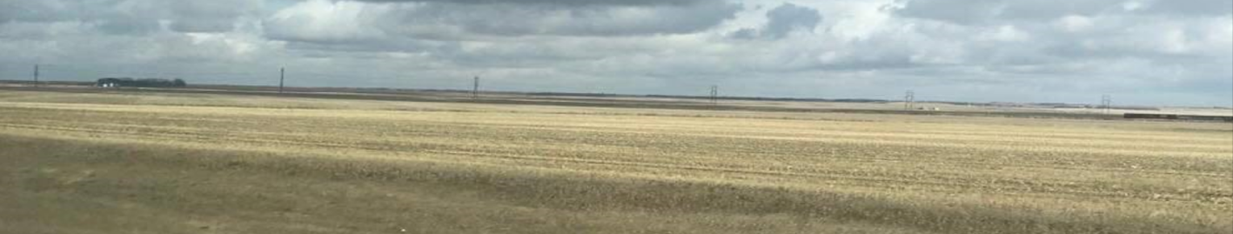
‘You make beautiful things. You make beautiful things out of the dust. You make beautiful things. You make beautiful things out of us’
Sitting in a land and being surrounded by so much tension through our exposure to the First Nation Issues, I am reminded how sometimes our lives resemble the barrenness of the land. Even in what seems to be the most beautiful is filled with despair. We are invited to see Creator God’s hand at work taking what is apparent and making or remaking it – fit for purpose.
Revd Philip Swan writes:
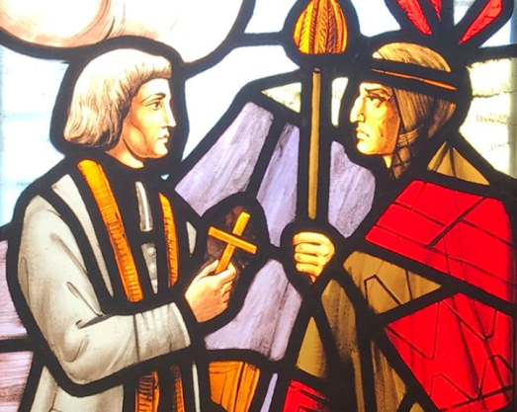
The very first words spoken at the meeting of the Diocesan Council were: ‘We are gathered today on Treaty 4 Territory. This is the traditional homeland of the Cree, Saulteaux, Dakota and Métis people and nations. We do this out of deep respect for the traditions, peoples and ceremonies that have been going on in this place for thousands of years and also as a reminder that reconciliation continues to be amongst our most important tasks’.
We were deeply moved. One of the recommendations coming out of the Truth and Reconciliation Process which has sought to provide ways of offering healing and reconciliation following the painful and until recently unacknowledged history of cultural genocide amongst the First Nation people, is that all meetings and gatherings on church premises should begin with this assertion.
Dean Mike Sinclair said that, as he starts every service in the cathedral with these words, there are those who clearly do not want to hear what is being said. A few congregation members have even left. But he cited a First Nation family who now attend and are so appreciative for these words. We are walking on holy ground.

Conclusion
We are most grateful for the support of the Fellowship of the Maple Leaf without which this visit could not have taken place and for the hospitality of Qu’Appelle Diocese. We engaged with several issues which face both of our dioceses and saw how creatively Qu’Appelle Diocese is developing team ministry, is engaging with ecumenical relationships and also how strategically it is using Intentional Interim Ministry. As a Diocese we hope now to explore establishing links with the Indigenous Church and to develop the school link we were able to initiate between Kingsland Academy in Stoke-on-Trent and Gordon’s School, Punnichy, Saskatchewan. It was the privilege of meeting First Nation people and connecting with the Truth and Reconciliation process which has particularly challenged, moved and inspired us, and provided insights which will stay with us as we journey on in ministry in the years ahead.

