Curates’ visit to Nordkirche
Nordkirche is the Evangelical Church of Northern Germany.
Bishop Michael was keen for a group to be in the Nordkirche on what was envisaged as being Brexit Day March 29th, as an expression of prayerful solidarity.

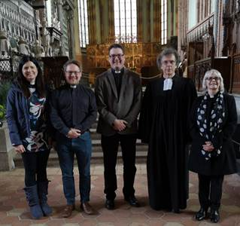

The group of four, including one second year curate Revd Gloria Harrison, spent a fruitful week in Güstrow and Rostock building on our friendship together and helping to shed some light on the highly confusing and complex Brexit process.

Bishop elect Tilman Jeremias wrote following their visit:

‘We all are really enriched by the visit of Gloria, Shell, Graham and Joshua! Especially we were impressed, how openly they told us about the complicated current political situation in the UK, but also about the reasons why so many people in the area of Stoke on Trent voted for ‘Leave’. Your diocese is blessed with these committed pastors!’.

