Curates’ visit to Matlosane
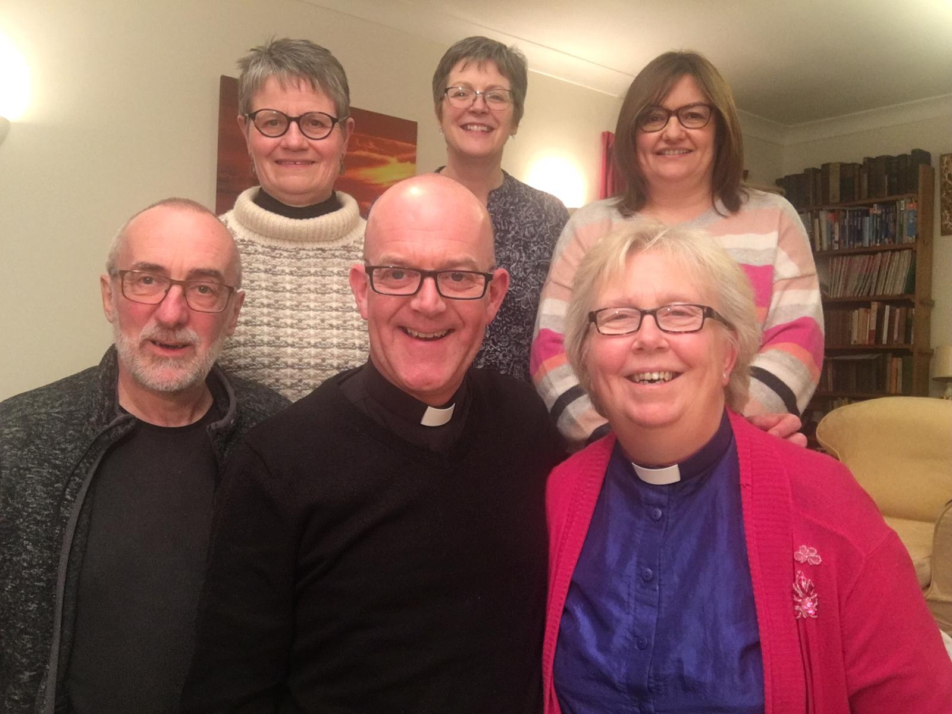

Revd Liz Mills writes:

The sun was already beating down as we arrived at the Cathedral of the Resurrection in Ikakeng. Matlosane is the only Diocese in the province of Southern Africa to have its cathedral in a township. We were there to celebrate ladies’ day. The day is chosen to coincide with the Feast of the Annunciation. As we began to process in the smell of incense fired my imagination and I found myself saying 'The Lord has done great things for me and holy is his name '.
As curates we were privileged to share in the distribution of Communion and also to bring the greeting of Bishop Michael. Bishop Steve preached and presided and there was much joy and singing! Everyone thanked everyone and spoke of the value of the partnership relationship we enjoy. The joy of our African brothers and sisters will remain with me always.
Cath Brumfit writes:
After lunch on Saturday I left the rest if the group and travelled three hours south to stay with the Revd Dr Rabebe and his family in Christiana. Despite being kept awake all night by a rather fierce thunder storm I made it to St Mary's Church in Christiana to preach at their 8am Service. The service lasted about two and a half hours so just a bit longer than I'm used to partly due to the amazing singing! Later in the afternoon I received a proper African welcome as the church councils from Christiana and Bloemhoff joined me at Dr Radebe’s home for lunch which was a Braai (BBQ) where I was introduced to pap (soft porridge) which is made of ground maize and often used instead of potatoes.
Monday was spent doing home communion and visiting the sick in Bloemhoff with Fr Dennisa. This is quite a slick affair with around 12 home communions done in two hours before visiting a nursing home for communion and laying in of hands. Everyone welcomed a visit from 'the priest from England' with many people asking for a blessing before I left their home. By the end of the morning I became known as 'Mother Kate'.

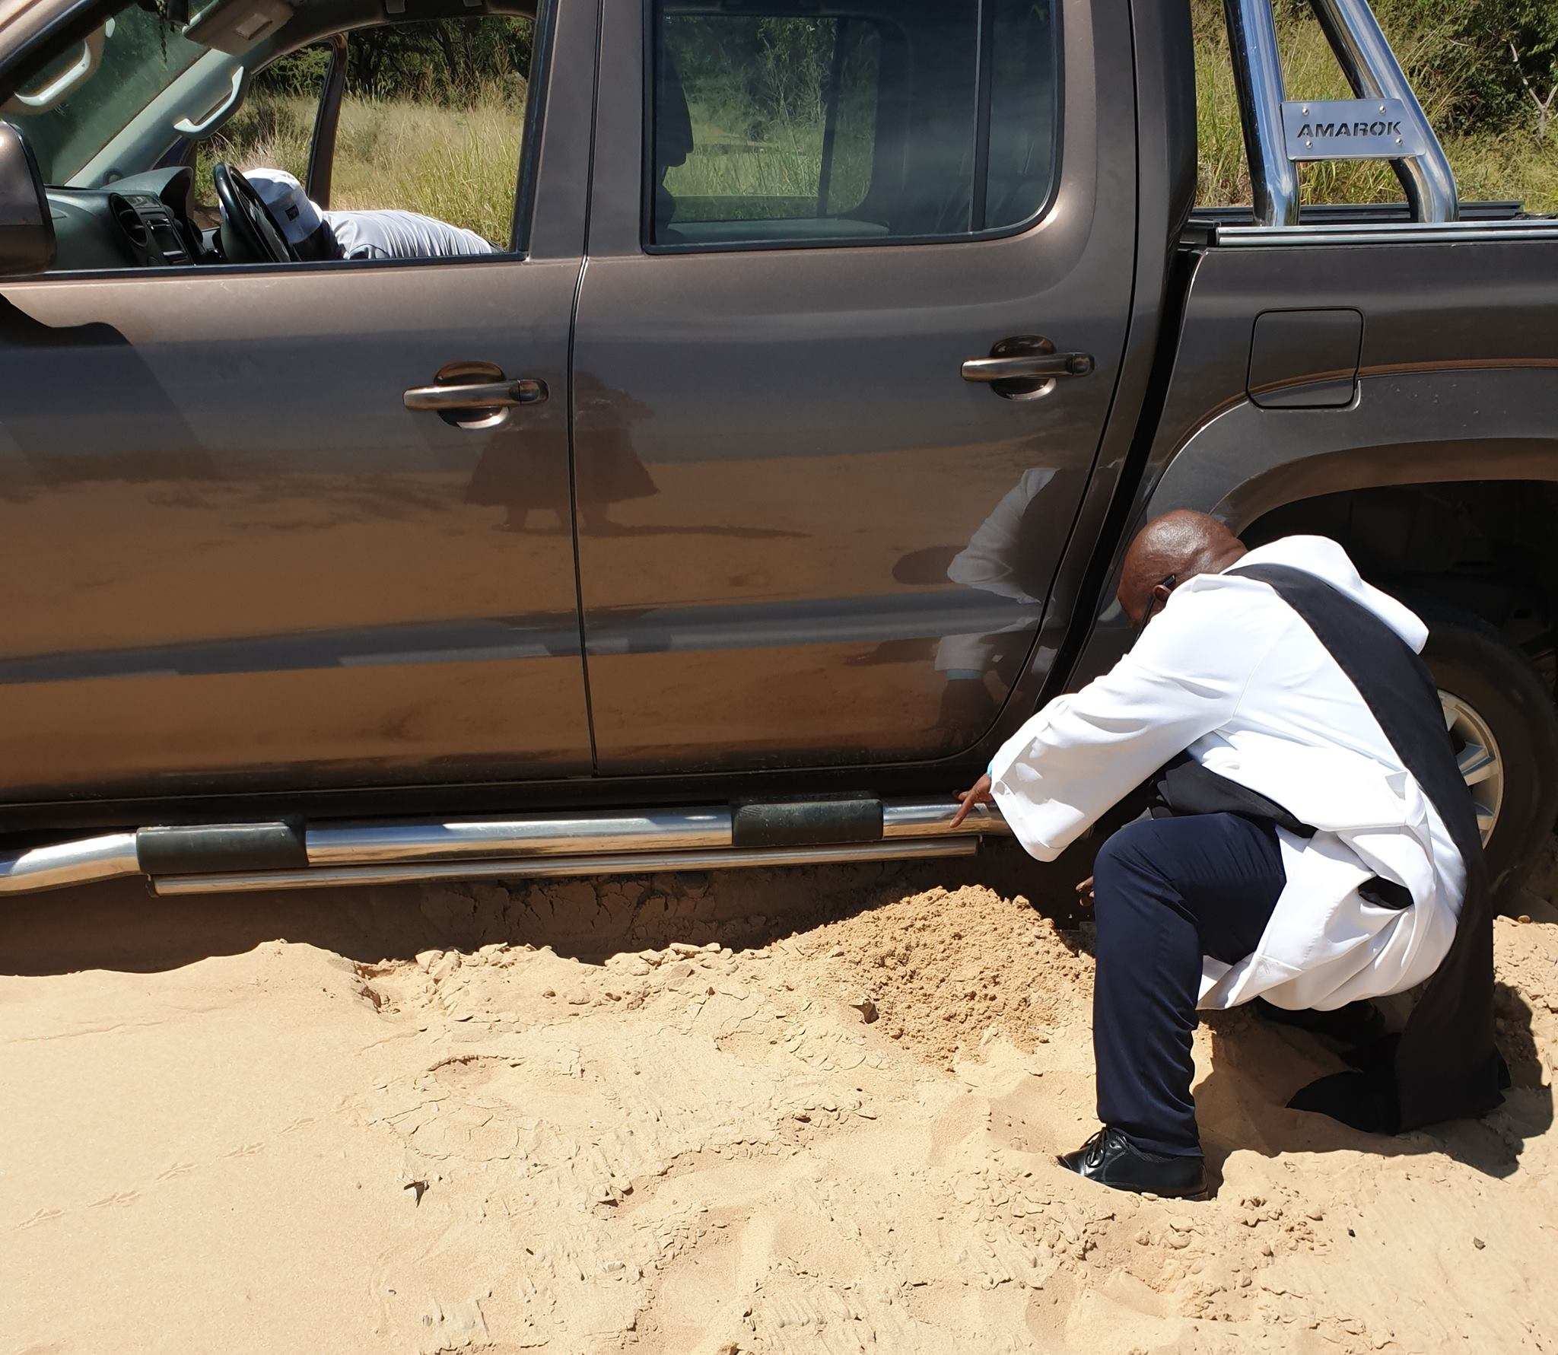

A visit to the dam at Bloemhoff added a bit of drama to the morning when our vehicle got stuck in the sand and Fr Dennis had to dig us out still dressed in full Robes.
Tuesday saw another morning of Home Communions this time in Christiana where we managed 15 in the same two and a half hours! In the evening I preached and presided at St Luke's in Bloemhoff. The African influence reached an even higher level with lots of dancing and singing...a truly joy filled service. At the end I was literally wrapped up in the gifts that they had bought me to remember them by!
Leaving Bloemhoff on Wednesday was extremely emotional, and as I said in my homily earlier that morning, I will always remember my time spent with them and that they will have a special place in my heart.
Liz Mills writes:
I spent the day taking home communions in the township of Kanana. After visiting ten homes our last visit was to Emily who set up a nursery for working mums. She wanted to help and support young women who would otherwise have been caught in a cycle of poverty with their children. An amazing woman serving Christ in her community.

