Persistent, unreasonable and/or vexatious complaints policy
Policy owner | CEO
Date adopted | March 2024
Review date | March 2025

Introduction
The identification and handling of an unreasonably persistent, malicious or vexatious complaint is not an easy task. Difficult or not, it is important that we all do all we can to protect each other from harm. Vexatious complainants often have a history of childhood trauma and longstanding relational difficulties, and this should be kept in mind when considering an appropriate way to set safe boundaries for all involved. This should help inspire empathy rather than hopelessness. Some complainants can cause huge damage to themselves and those they are complaining about if not effectively managed.
In designing this policy, the working group have been committed to a balanced approach to complaints. We acknowledge the need to ensure all complaints are taken seriously and it is our priority to hear real complaints even if made in a dysfunctional way. All complaints should be responded to individually. Having said that we also seek to offer clergy, church officers and employees robust protection from unnecessary abuse by complainants. In summary our duty is to ensure all are safeguarded and can flourish.
Complainants may initially direct their complaints to any of a number of places but in the first instance should be sent to the local parish who, when necessary, may seek the guidance of the local Archdeacon. A model parish complaints policy is available for parishes in Appendix 1. This can be individually tailored at PCC level. If either party is dissatisfied with the way the complaint is progressing or it is unable to be resolved locally, the Archdeacon or his /her Associate can advise how and when to escalate the complaint.
This policy deals only with the management of abusive, unreasonably persistent, and/or vexatious complainants that cannot be resolved by the ordinary procedures as laid out in the Diocesan Guidelines for clergy . It sets out how all those affected might deal with complainants that fall within the scope of this definition. Those identified will be treated consistently, honestly and proportionately. This policy applies across the Diocese.
It is acknowledged that all complainants have the right to have their concerns examined in line with the generic Diocesan complaints policies (including but not limited to whistle-blowing, grievance or disciplinary). In most cases, dealing with complaints will be a straightforward process; however, in a minority of cases, the complainant may act in a manner that is deemed unacceptable.
They may act in a way that is considered abusive, unreasonably persistent or vexatious and by doing so it may hinder our ability to investigate their complaint or the complaints of others. This behaviour may occur at any time before, during or after a complaint has been investigated.
The time spent on dealing with all complaints should be proportionate to the nature of the complaint and or the distress of any of the parties involved. It should be consistent with the outcome that is being sought and be realistic and achievable.

1. How is unreasonable complaint behaviour defined?
It should be noted that raising a complaint about a member of the Diocesan staff or clergy does not in itself constitute unreasonably persistent behaviour and neither do complainants who escalate through all stages of the relevant complaints procedure or those who express criticism about the complaints process itself.
If a complaint appears to be complex and there is an extraordinary level of distress or a breakdown in communication, it should be considered very early in the process if additional support needs to be given to either party whilst the complaint is on-going. It may be helpful at this point to set out the expectation of boundaries, behaviour and communications of all parties throughout the process.
Generally, the Diocese seeks to adopt the Local Government Ombudsman's definition and the identified characteristics for unreasonable or unreasonably persistent complainants "For us, unreasonable and unreasonably persistent complainants are those complainants who, because of the nature or frequency of their contacts with an organisation, hinder the organisation's consideration of their, or other people's, complaints".

Examples of unreasonable and unreasonably persistent behaviour
(this list is not exhaustive, nor does one single characteristic on its own imply that the person will be considered as being in this category)
- Refusing to specify the grounds of a complaint, despite offers of help.
- Refusing to cooperate with the complaints investigation process.
- Refusing to accept that certain issues are not within the scope of either the parish's or diocese's jurisdiction or within the scope of a complaint's procedure.
- Insisting on the complaint being dealt with in ways which are incompatible with the adopted complaints procedure or with good practice.
- Making unjustified complaints about officers and clergy who are trying to deal with the issues and seeking to have them replaced.
- Changing the basis of the complaint as the investigation proceeds.
- Denying or changing statements he or she made at an earlier stage.
- Introducing trivial or irrelevant new information at a later stage.
- Raising many detailed but unimportant questions, and insisting they are all answered.
- Submitting falsified documents from themselves or others.
- Adopting a 'scatter gun' approach: pursuing parallel complaints on the same issue with various members of staff and/or organisations.
- Making excessive demands on the time and resources of staff with lengthy phone calls, emails to diocesan staff and senior clergy or detailed letters every few days and expecting immediate responses.
- Submitting repeat complaints with minor additions/variations, which the complainant insists are 'new' complaints.
- Refusing to accept the decision; repeatedly arguing points with no new evidence.

Examples of abusive and/or vexatious behaviour
The diocese will take steps to protect its staff from members of the public who are behaving in a way which is considered abusive and/or vexatious. This may include physical or verbal abuse and could include the following (however this list is not exhaustive):
- Speaking to the member of staff in a derogatory manner.
- Swearing, either verbally or in writing.
- Using threatening language towards staff and clergy.
- Repeatedly contacting a member of staff regarding the same matter which has already been addressed.

Examples of unreasonable behaviour
- Complaining about a wide variety of unrelated issues and people.
- Employing traditional methods of emphasis with high frequency (i.e. underlining, bold)
- Using threats or intimidation, including threats of violence.
- Being overtly offensive
- Pursuing the complaint for a duration which is not proportionate to the nature of the complaint.
- Focusing on personal vindication or retribution.
- Demanding retribution by prosecution or dismissal.
- Demanding public exposure and humiliation of the respondent or organisation.

2. Record Keeping
This is a vitally important part of being able to address concerns. Individual parishes, the diocesan office, bishops' and archdeacons' offices should keep a record of all complainants who have been treated as being unreasonably persistent, abusive and/or vexatious in accordance with this policy. These records will include details of why the policy was invoked, what restrictions were imposed and for what time-period. Record keeping needs to be excellent at all levels so that it is easy to identify those who have history of complaining behaviour. Training needs to be available to those who seek it. Information sharing may be necessary to be able to identify the kinds of complaining behaviour set out in section 2 and this may be requested by either parish or diocesan officers.
A sample record of harassment for is available as appendix 2.

3. Managing unreasonable complainant behaviour
This policy may be invoked if the recipient of the complaint considers that a complainant has behaved in a manner which is deemed unreasonable or unresponsive and has not adhered to the expectations set out in our initial response letter. At this stage the initial recipient will escalate the complaint to the Diocesan office for action. Once investigated the Diocese may take any actions against a complainant that it considers to be reasonable and proportionate in the circumstances.
Types of actions the Diocese may take:
- Where the complainant tries to reopen an issue that has already been considered by other complaints' procedures, they will be informed in writing that the procedure has been exhausted and that the matter is now closed.
- Where a decision on the complaint has been made, the complainant should be informed that future correspondence will be read and placed on file, but not acknowledged, unless it contains important new information
- Limiting the complainant to one type of contact (e.g. telephone, letter, email, etc.)
- Placing limits on the number and duration of contacts with staff per week or month
- Requiring contact to take place with a named member of staff and informing the complainant that if they do not keep to these arrangements, any further correspondence that does not highlight any significantly new matters will not necessarily be acknowledged and responded to, but will be kept on file
- Assigning one member of staff to read the complainant's correspondence, in order to ensure appropriate action is taken
- Offering a restricted time slot for necessary calls to specified dates and times
- Requiring any face to face contacts to take place in the presence of a witness and in a suitable location

4. Matters to consider before taking action
Before taking a decision to invoke this policy consideration should be given to whether any further action is necessary, such as:
- Consideration about whether it is appropriate to convene a meeting with the complainant and a senior officer in order to seek a mutually agreeable resolution.
- If it is known or suspected that the complainant has any special needs, then consider offering an independent advocate who may assist the complainant with their communication with the diocese.
- Where more than one department/parish is being contacted by the complainant, agree a cross functional approach; and designate a lead officer to co-ordinate the diocese's response.
Staff must be satisfied before taking any action as defined by this policy that the complainant's individual circumstances have been considered including such issues as age, disability, gender, race and religion or belief. Reference can be made to other Diocesan groups when required, e.g Racial Justice Team

5. Imposing restrictions
In the first instance the diocese in consultation with the relevant archdeacon will communicate to the complainant either by phone or in writing to explain why this behaviour is causing concern and ask them to change this behaviour. The diocese will explain what actions it may take if the behaviour does not change.
If the complainant continues with the unreasonable behaviour the diocese will consult with their lawyer about whether it is necessary to take appropriate action by invoking this policy.
When the decision has been taken to apply this policy to a complainant, the Diocese will contact the complainant in writing (and/or as appropriate) to explain:
- why this decision has been taken
- what action the Diocese will be taking
- the duration of that action
- the review process of this policy
Any restriction that is imposed on the complainant's contact with the diocese will be appropriate and proportionate and the complainant will be advised of the period of time the restriction will be in place for. In most cases restrictions will apply for between three and six months but in exceptional cases may be extended. In such cases the restrictions would be reviewed on a quarterly basis.
If the complainant continues to behave in a way which is deemed unacceptable then the diocese, in consultation with the relevant archdeacon and legal services, may decide to refuse all contact with the complainant and cease any investigation into his or her complaint.
Where the behaviour is so extreme or it threatens the immediate safety and welfare of staff or clergy, the diocese will consider other options, for example reporting the matter to the police or taking legal action. In such cases, we may not give the complainant prior warning of that action.

6. New complaints from those who have been treated as being abusive, vexatious and/or unreasonably persistent complainants
Any new complaints received from complainants who have come under this policy will be treated on their merits.
The diocese does not support a blanket ban on genuine complaints simply because restrictions may be imposed upon that complainant.

7. Review
The diocese will review any restrictions which are imposed upon the complainant after three months and at the end of every subsequent three months within the period during which the policy is to apply.
Should the decision be taken to extend the period of restriction, the complainant will be advised in writing how the Diocese plans to go about this and that the decision to restrict contact will be put in place for a further specified period (e.g. six months). The outcome of any subsequent review will be communicated to the complainant, outlining if the restrictions will continue to apply and if so why.
If at the end of the restricted period it is considered that the complainant's behaviour is no longer deemed to be unreasonable, the Diocese will confirm this in writing advising that the restrictions have now been lifted.

Appendix 1- template parish policy
https://parishresources.org.uk/pccs/policies/
or

Parochial Church Council

Complaints Policy And Procedure
The members of XXXXXX (PCC) are committed to their role which primarily involves “cooperation with the minister in promoting in the parish the whole mission of the Church, pastoral, evangelistic, social and ecumenical.” (from the Parochial Church Councils (Powers) Measure 1956)
This policy has been written to ensure, as far as possible, that the Church family is happy, healthy and holy, as the scriptures teach:
As God’s chosen people, holy and dearly loved, clothe yourselves with compassion, kindness, humility, gentleness and patience. Bear with each other and forgive one another if any of you has a grievance against someone. Forgive as the Lord forgave you. And over all these virtues put on love, which binds them all together in perfect unity. Colossians 3:12-14
There are two different kinds of complaints covered by this policy:
Complaints about the wrong behaviour of someone in church. This could be the wrong behaviour of the vicar, staff, PCC members or another church family member.
Complaints about an issue for which the PCC is responsible. This could be related to the safety or poor condition of the church buildings, grounds, finances, equipment, policies or practices which have affected you.

Making a complaint when someone’s behaviour is thought to be wrong – the biblical view
Christians are taught not to complain as a first option but rather we are to ‘do everything without complaining or arguing’ (Philippians 2:14).
Yet, as Christians we need to take responsibility for our behaviour before God and each other. We are taught that ‘if a brother or sister sins, go and point out their fault, just between the two of you.’ (Matthew 18:15).
There are times when we need the support and help of others to do this, like in the church in Philippi, when two women, Euodia and Syntyche, had fallen out:
I plead with Euodia and I plead with Syntyche to be of the same mind in the Lord. Yes, and I ask you, my true companion, help these women (Phillippians 4:2-3)
And Jesus said:
if they will not listen, take one or two others along, so that ‘every matter may be established by the testimony of two or three witnesses.’ (Matthew 18:16)

What to do when problems arise with someone’s bad behaviour and who to talk to.
If there is someone who is behaving in a way which the Bible says is wrong, and you want support to address the problem, then you should take that problem to people who have the responsibility listed in the table below.
Bad behaviour of | Talk to | Phone number | Email
The vicar, | The wardens and/or leadership team
A member of staff, | The wardens and vicar
A member of the church council | The wardens and vicar | (see above)
Another church family member | The vicar and assistant pastor | (see above)

The people you talk with will make sure that what you say is
- listened to
- treated seriously
- handled fairly without bias or discrimination
- treated confidentially
You will be asked to talk with, or write to, one or more people listed. After you have made a verbal or written complaint, the people responsible for handling your complaint will aim to get back to you within 10 working days (annual vacations or sickness permitting).
The problem will be addressed by the responsible people you have talked to; they will seek to establish the facts of the matter and, depending on the kind of behaviour, will either seek to bring peace by a process of reconciliation OR protection for you (and others) from that bad behaviour. Behaviour will be considered in the light of the teaching of the Bible which gives us God’s standards of good and bad behaviour.
A confidential record of conversations or communications will be kept for an appropriate period of time, either until the matter is resolved or for a specified period afterwards.
The Bible teaches that peace is made possible by the commandments and grace of Jesus. If anyone responsible for bad behaviour is humble, apologises, seeks forgiveness or makes redress and then asks for help to change, then forgiveness and peace should follow, though this process might be difficult and take time.
If the matter is of a sufficiently serious nature the wardens, assistant pastor or vicar will inform the relevant safeguarding officers, diocesan staff or statutory authorities, social services or police, and let due process be followed.

Making a complaint to the PCC
If your complaint is focused on an issue which the PCC is responsible for, such as the buildings, grounds, finances, equipment, policies or practices, and this has affected you, then complaints should be made in writing or by email to the PCC Secretary whose name and contact details are set out below. The PCC Secretary will ensure that your complaint is:
- treated seriously
- handled fairly without bias or discrimination
- treated confidentially.
You should complain within 3 months of the event that you are complaining about. You need to set out:
- your full name and address
- what you think went wrong and how it has affected you including enough details to show why you are aggrieved
- what (if anything) you think the PCC should do to put it right
If someone else complains on your behalf, the PCC will need written confirmation from you saying that you agree for that person to act for you.
The PCC Secretary should immediately record receipt of a complaint in a log.

How your complaint will be dealt with
The PCC Secretary will write to you or send you an email to confirm receipt of your complaint within 10 working days of its receipt (vacations and sickness permitting) and arrange for it to be considered by the PCC’s Complaints Committee. If your complaint refers to particular individuals who are members of the Complaints Committee it will meet without them being present.
The PCC’s Complaints Committee will look fairly into your complaint including seeking the views on the matter from any individuals, whether members of the PCC or otherwise, to which your complaint refers. The Complaints Committee may appoint one or more persons to look into the matter on its behalf but it will be the Complaints Committee that makes any decisions. The Complaints Committee and any such appointed persons will treat the matter confidentially.
The Complaints Committee may invite you to present your complaint to them. If so, you may attend with a friend / representative if you wish. The meeting should be held as informally as possible. The Chair will explain the purpose of the meeting, introduce the members and emphasise confidentiality. The meeting will be minuted by the Committee.
The PCC Secretary will write to you with the conclusions from the PCC Complaints Committee’s review and reasons for that outcome. The PCC Secretary will aim to respond to you in this way as soon as possible, and no longer than 6 weeks after the receipt of your complaint (holidays and sickness permitting).
This will be the PCC’s final response to your complaint.

Vexatious Complaints.
The presumption will be that a complaint is made in good faith. If the complaints committee becomes aware that the complaint is made with vexatious or malicious intent they may make a decision and recommendations for further action on this basis.
Every complaint will be considered on its merits and, even if someone has made a vexatious or malicious complaint in the past, it must not be assumed that any other complaint they make will also be vexatious or malicious.
If the complainant fails to agree with the resolution suggested and continues to persist in a querulant or vexatious manner , the PCC should refer the complainant to the Diocese who will consider the complaint and if necessary refer to its vexatious complaints policy.

Appendix 2 - Expectations of complainants and respondents

Expectations and responsibilities of complainant and respondent

The Parish/Diocese as respondent will:
- ensure unacceptable behaviour is never tolerated in any form.
- develop an organizational culture where people’s differences are actively valued and included.
- ensure those experiencing or witnessing bullying, harassment, unlawful discrimination or victimisation know how to report it and are aware of the support available to them.
- ensure when cases are reported that we respond promptly, sensitively and appropriately.
- acknowledge complaints within 48 hours.
- keep a formal record and outline our process of investigation thoroughly and adhere to the process an where reasonably possible to the timelines laid down.
- take every complaint seriously.
- treat complainants with courtesy.
- Maintain record keeping in line with GDPR best practice.

The complainant will:
  - engage in the process and do all they can to make the attempts at resolution succeed at the lowest possible level.

  - explain or document the matter accurately and in sufficient detail, stating clearly what redress or outcome they are seeking and ensuring this is reasonable and practicable.
  - give adequate notice to Respondents if they wish to discuss the matter face-to-face and provide at least five working days’ notice if they wish a companion to be present.
behave with courtesy and not subject any staff to abuse or harassment.

Appendix 3- flow charts –

a) for parishes
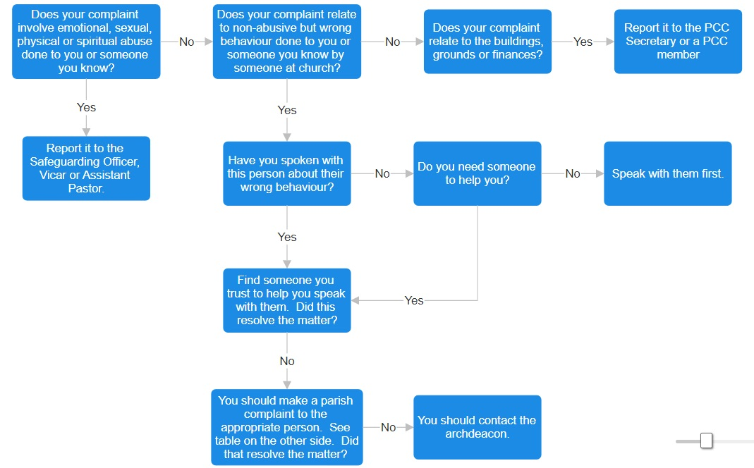

b) for the diocese
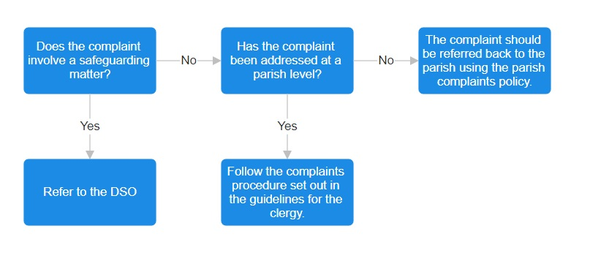

Appendix 4- record of harassment

Date | Time | Location | Incident (factual record) | Witnesses | How this made you feel

