Where Do We Find Hope?

# Ven Sue Weller’s Sermon for the first Sunday in Lent, 21 February 2021

Genesis 9:8-17, 1 Peter 3:18-end, Mark 1:9-15

What things come to mind for you in this pandemic now in its second year?

For me it includes the optimism and resilience of Sir Captain Tom Moore, and his message of hope that ‘*tomorrow will be a good day*’.

We continue to see the fragility of life in the face of COVID 19 here and around the world. There is the determination to keep going despite exhaustion and death, and the incredible science that has given us vaccines so quickly. The pandemic is affecting all of us, including for many fear, as jobs and valuable education are lost, and there continues to be uncertainty of what the future might hold.

Yet not everyone seems to be on the same side. Often the news gives us examples of the selfishness of those intent on breaking the law, putting themselves and others at risk, or the bitter ongoing battles between governments of who gets the vaccines and when.

Whatever comes to mind for you, there is one over riding symbol, that we will all have seen. A sign of trust in and thanks for our NHS and all key workers, based on their skill and commitment - the rainbow. A sign too of our promise to play our part. We hope things will get better, we hope we will come out the other side, we hope that we can return not to normal life, but to a new life, changed for the better by the pandemic.

Where does that hope come from?

The morning after the UK reached the heart-breaking total of 100,000 deaths, for any reason within 28 days of a positive COVID test, BBC Breakfast asked the question, where do we find hope in this pandemic? They interviewed the Archbishop of Canterbury, Justin Welby. His answer to the question, where do we find hope? Was ‘*I find* ***my*** *hope in Jesus Christ’*. He went on to say, ‘*death does not have the final word, God has the final word. God is with us in the anger and the pain’*.

I find **my** hope in Jesus Christ.

On this first Sunday in Lent, our readings show us that we can all have that same enduring, concrete, certain hope.

God knows us as we are, God knows that there is suffering, injustice, and evil in this world. Our solution if asked, might often be, why doesn’t God just wipe out those things that are wrong? The pandemic, violence, selfishness… but that doesn’t solve the problem. Not one of us is perfect, including me. So where would God draw the line?

The reading today from Genesis 9 begins to point us to a very different solution. Genesis tells of God’s promise *for all generations to come*, *God said to Noah* that *all life will never be destroyed again* – *I have set my rainbow in the clouds, and it will be the sign of the covenant (the promise) between me and the earth.*

The stunning beauty seen in the rainbow is a reminder of God’s promise not to destroy all life; something God would have to do to wipe out all that is wrong in this world. But God’s promises don’t end there. God promises to save us.

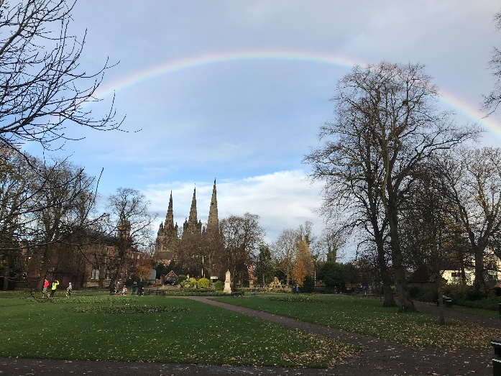

In possibly the most well-known verses in the Bible, John Chapter 3: 16-17, we read ***16****For God so loved the world that he gave his one and only Son, that whoever believes in him shall not perish but have eternal life.****17****For God did not send his Son into the world to condemn the world, but to save the world through him.*

God doesn’t abandon us to battle on in our own strength, fearful of the future, fearful in the present, we are offered life that not even death itself can take away. We can’t buy eternal life; we can’t work for it; we can’t inherit it as we would a family heir loom. Only God can give us life, saving us through Jesus Christ.

As Jesus’ disciple Peter wrote in his first letter, that we’ve read today, 1 Peter 3:21 reads, *we are saved by the resurrection of Jesus Christ.* 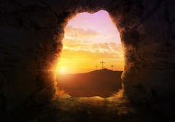

Christ, a young man in his thirties, went through horrific suffering, to save us, bearing all that is wrong in our lives, bearing the sins of the world. Christ died on the cross for you and for me. Christ was buried and on the third day **was raised to life** by the Holy Spirit. The tomb is empty.

God is not distant, leaving us to get on with life having promised not to destroy us. In our reading from Mark’s Gospel, Chapter 1, God the Father declared that Christ is the Son of God. **11***And a voice came from heaven: “You are my Son, whom I love; with you I am well pleased.”* Led by the Holy Spirit into the wilderness for 40 days, Christ overcame the temptations of Satan. On his return he begins his adult ministry announcing the good news to the people – “*The kingdom of God has come near. Repent and believe the good news*!”

Jesus Christ is as alive today, as he was that first Easter following his resurrection. He conquered sin and all its consequences including death and destroyed the power of Satan. Christ smashed through all that separates us from God and each other.

*“The kingdom of God has come near. Repent and believe the good news!”*

God is with us and offers us the gift of living life in the presence of God, knowing the love, power and hope found in Christ. *The kingdom of God has come near*.

Knowing that God is close to us, how do we respond?

Christ calls us to *Repent and believe the good news!*

Repent, *to turn away from* living life our way, and *turn to* Christ. And to believe – to believe in Him, trust Him in every part of your life, receive all He longs to give you.

Find hope in the face of suffering and death, faith to see God at work in you and the world and know the love your heavenly Father has for you, his precious child.

During this pandemic, with a long way still to go, it may feel that it is too much to face the reality of your need of God and do something about it. Even if that something, turning to Christ and trusting in Him, will give you true and lasting hope. Yet in this season of Lent, knowing all is not OK, take the opportunity to stop, be open and honest with God. Turn to Christ and know the forgiveness of God. Take the opportunity thorough Lent to read or listen to the Gospel of Mark, either for the first time, or having done so many times before. Turn to God and believe in Him.

Be embraced by the God who loves you in this life, as well as the life to come, find hope in Jesus Christ, that today, as well as tomorrow, despite suffering, fear and uncertainty, will be a good day.

Gracious God,  
as we remember before you the thousands who have died,  
surround us and all who mourn with your strong compassion.  
Be gentle with us in our grief,  
protect us from despair,  
and give us grace to persevere and face the future

with hope in Jesus Christ our risen Lord.  
**Amen**.