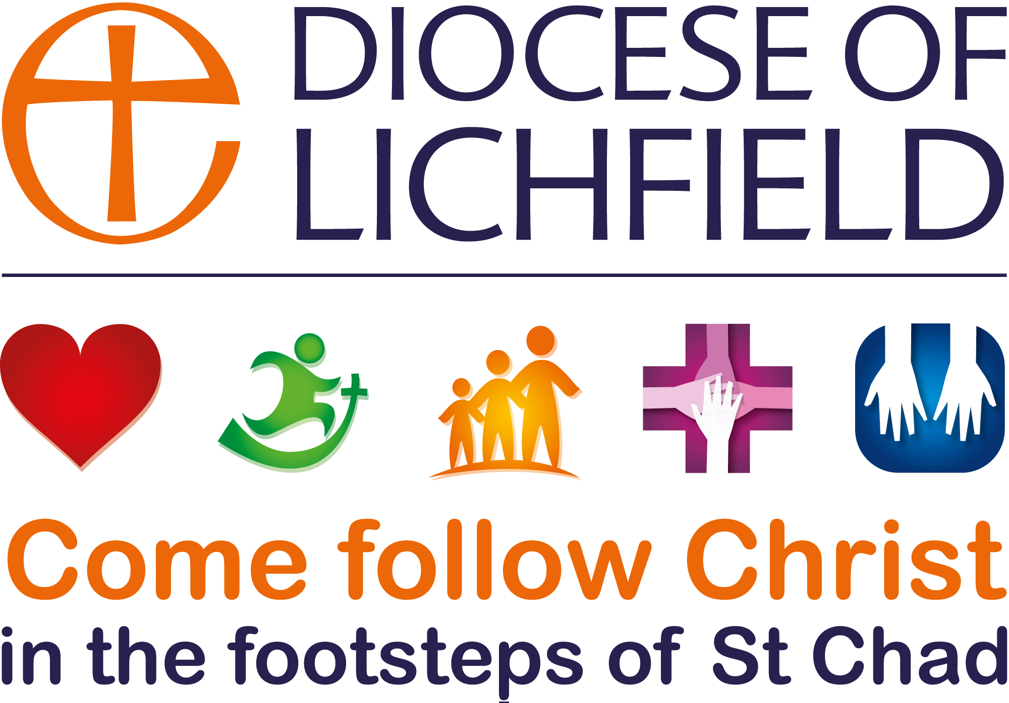

DECLARATION BY CHURCHWARDENS
Please complete the form below and forward it to your Archdeacon once you have been admitted as a churchwarden.
DEANERY:
ADDRESS:

EMAIL:

TELEPHONE: (Please indicate preferred contact)
Home: Mobile: Work:
Notes:
- You will find further information about the duties of a churchwarden on the Diocesan website.
- The disqualifications are (a) disqualification as a charity trustee under s.72 of the Charities Act 1993; (b) convictions within Schedule 1 to the Children and Young Persons Act 1933; and (c) disqualification under section 10(6) of the Incumbents (Vacation of Benefices) Measure 1977. If you are in any doubt as to whether you are disqualified, please consult the diocesan registrar before signing this form.
I declare that:
- I will faithfully and diligently discharge the duties of the office of churchwarden for the above parish during the period of my appointment.
- I am not disqualified from holding office as a churchwarden under section 2(1), (2) or (3) of the Churchwardens Measure 2001 and I hold a current enhanced DBS certificate.
- I consent to the use by the Archdeacon and the diocese of the personal data entered on this form for the purposes of communication with respect to the office and role of churchwarden.

Please sign here: Date:
YOUR NAME:
CHURCH & PARISH:
DBS CERTIFICATE: Number: Date:
Please note that if you are not able to provide this you will not be admitted to office. You do not show your DBS disclosure itself, only the number and date are required.

