Dementia-Friendly Churches -Physical Environment Checklist

Clive Rogers comes to Leaton Church

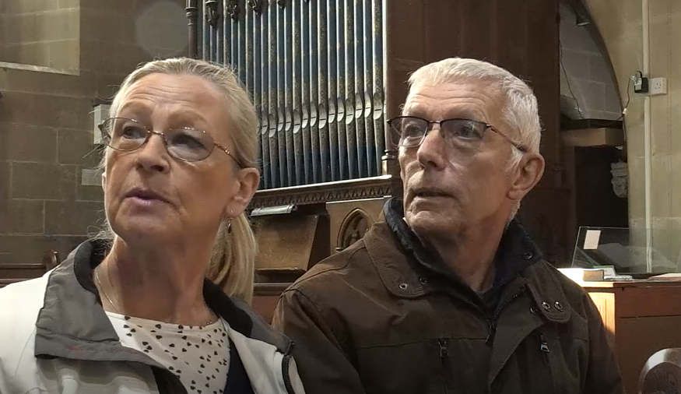

This Checklist accompanies the 10-minute film in which Clive and Barbara Rogers go round Leaton Church in Shropshire: https://youtu.be/XhSa1v2IIXU Clive used to be a Flight Lieutenant in the RAF; he was diagnosed with mixed dementia in 2017 – Alzheimer’s Disease, frontotemporal dementia and vascular dementia. As Clive and Barbara go round Leaton Church, near Shrewsbury, Clive explains what’s helpful and what’s difficult. You can read more about Clive and Barbara Rogers’ story here: Making the days count: After a dementia diagnosis, a Shrewsbury couple share their story | Shropshire Star

After watching the film, use this checklist to review your own church for dementia-friendliness.
What’s the impact? Clive’s reflections / suggestions | Notes from reviewing our own church

Signage
It can be helpful to add simple laminated signs, with arrows and/or pictures as necessary, to navigate round the building.
- Black writing on a yellow background is clear.
- On arrival, is there a sign showing the way to the main door of the church?
- Which way to the toilet?
- On the toilet door itself, add a sign with words and pictures.
- Also (although not covered in the film) signs showing the way to the exit door and the door itself can be helpful.

Lighting
Shadows and half light can be difficult: poor lighting can impact on peripheral vision and balance.
- Coming into church, it is important that the entrance/porch is well lit.
- Good clear lighting inside church makes a real difference.

Toilet
It’s helpful if the fittings are in plain constrasting colours so that they are clearly visible.
- It’s helpful if the toilet seat is a contrasting colour to the walls and the rest of the toilet.

Flooring and mats
Some colours of carpet can be more difficult: the plain blue carpet worked well.
- A black mat or black flooring is difficult: it can look like a hole.
- It’s helpful to have the carpet the full width of the aisle: if there’s a black grill at the edge of the carpet, that can look like a hole/gully.
- Checkered floors or patterned floors/tiles can be difficult: busy floors are not good.
- Also (although not covered in the film) a shiny floor surface can be difficult: it can look like water.

Steps
- Yellow and black tape or a colour contrast can help to mark a step clearly.
- For a step at the lectern, to stand on to read a lesson, balance can be an issue. So a step with handles would help – or otherwise someone giving a helping hand of support.

Notices, noticeboard & screens
- Black writing on yellow is clear.
- It helps if the notices / noticeboards / screens are at eye level: if you have to look upwards, it’s easy to lose balance.
- It’s helpful if the notices / noticeboards / screens are not too busy/cluttered.

For some issues that are unhelpful for dementia-friendliness, there is a simple, cost-effective solution e.g. adding laminated signs. Here, it’s good to go ahead and make straightforward changes. It’s also important to communicate why we’re doing so. As we name and face dementia together, we increase awareness and we open up connections and conversations: that’s all part of becoming a more dementia-friendly church.

We may identify other issues which are not a “quick fix”, perhaps because they would require significant expenditure e.g. upgrading lighting or changing flooring. Here, we might add the change to the “wish list” for the next refurbishment. We can also share our understanding and offer support e.g. a offering a steadying hand when walking over a checkered floor.

More about Dementia-Friendly Physical Environment
- Alzheimer’s Society “Dementia-friendly environment checklist”: https://www.alzheimers.org.uk/get-involved/dementia-friendly-resources/organisations/dementia-friendly-environment-checklist
- DSDC, Stirling University: The Dementia Services Development Centre at Stirling University Dementia Services Development Centre (stir.ac.uk) includes research / information / resources on a dementia-friendly physical environment.
- The dementia environment at home: For more about a dementia-friendly physical environment at home, here’s a helpful 12 minute video.

More about our Dementia-Friendly Churches and Schools Network
The Dementia-Friendly Churches and Schools network in the Diocese of Lichfield brings together communities across Staffordshire, The Black Country and north Shropshire. We work together to increase understanding about dementia, listening to its impact and learning from one another as we stay in step with people living with dementia. We are glad to journey together, becoming more dementia-friendly.
Dementia-Friendly Churches https://www.lichfield.anglican.org/inclusion/dementia-friendly-church/

Dementia-Friendly Schools
https://www.ldbe.co.uk/becoming-dementia-friendly-schools/

For more information contact
Sarah Thorpe, Dementia-Friendly Church Enabler, Diocese of Lichfield
E: sarah.thorpe@lichfield.anglican.org
T: 07982 248949
