Jesus is different; he makes things different

# Transfiguration Sunday; Racial Justice Sunday; Valentine’s Day.

# Simon Foster’s Sermon for 14 March 2021

## 2 Corinthians 4.3-6

And even if our gospel is veiled, it is veiled to those who are perishing. In their case the god of this world has blinded the minds of the unbelievers, to keep them from seeing the light of the gospel of the glory of Christ, who is the image of God. For we do not proclaim ourselves; we proclaim Jesus Christ as Lord and ourselves as your slaves for Jesus’ sake. For it is the God who said, ‘Let light shine out of darkness’, who has shone in our hearts to give the light of the knowledge of the glory of God in the face of Jesus Christ.

## Mark 9.2-9

Six days later, Jesus took with him Peter and James and John, and led them up a high mountain apart, by themselves. And he was transfigured before them, and his clothes became dazzling white, such as no one[*](javascript:void(0);) on earth could bleach them. And there appeared to them Elijah with Moses, who were talking with Jesus. Then Peter said to Jesus, ‘Rabbi, it is good for us to be here; let us make three dwellings, one for you, one for Moses, and one for Elijah.’ He did not know what to say, for they were terrified. Then a cloud overshadowed them, and from the cloud there came a voice, ‘This is my Son, the Beloved;[*](javascript:void(0);) listen to him!’ Suddenly when they looked around, they saw no one with them anymore, but only Jesus.

As they were coming down the mountain, he ordered them to tell no one about what they had seen, until after the Son of Man had risen from the dead.

Be our living word O God, Father Son and Holy Spirit. **Amen.**

I want to invite you to stand with me in front of a picture. It is a picture that speaks of the two themes of this day – the *transfiguration* – and racial justice Sunday.

It is a picture that I bought in my early twenties, and it has hung on my wall ever since. I was not then a Christian: it would be another fifteen years until I was baptised. But I knew even then that the man at the centre of this picture was important to me.

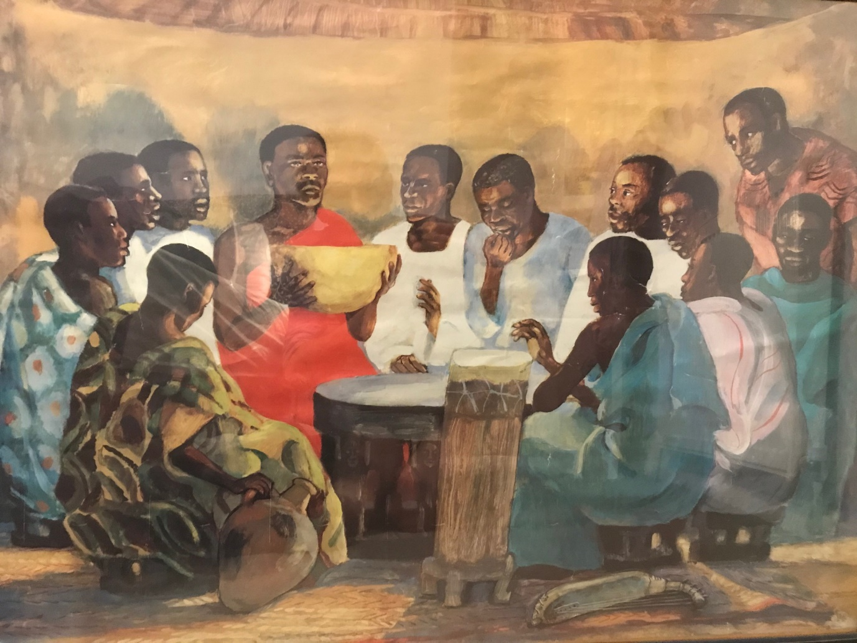

It is a profound, but joyful picture; a picture of Jesus gathered with his followers. Here is God’s kingdom; and looking at it, you, and I, are standing on the edge, seeing it from a doorway, perhaps.

You are right to be thinking that this is a picture of the last supper. But it is more than that: the painter has brought the essence of the **transfiguration** into the picture, as much, even, as the last supper. The transfiguration, the story we just heard from Mark’s gospel, is the point where the disciples suddenly see for sure that they are dealing with someone who is different.

In this picture, as in the transfiguration Jesus seems transformed in front of his close friends and disciples: he is different; the light of heaven – we call it **glory** – pours onto Jesus, clothes and all. I love how the artist has taken Jesus’ clothes, ‘dazzling white, such as no-one on earth could bleach them’ and chosen to make them an extraordinary, vivid red. I wonder why?

We see that Jesus’ attention is on the things of heaven, even while his feet rest on earth. He is connected to God, confident to marshal God’s kingdom in this world. Even the room where we see him feels as if it is becoming God’s kingdom, because he is in charge of it.

Jesus is different, the picture seems to say; and he makes things different.

And I think that’s why I chose it to be – it turned out - my lifelong companion of faith: so that I could wonder, daily, at how he is different, and how he makes things different.

But I think I chose it because this picture held another truth, too, although I didn’t fully understand that at the time. For it reminds us that Jesus’ world was totally different from ours. Like Jesus’ community, the people in this picture live in a culture untouched by Western life; their clothes, home, furniture, and musical instruments are different from what I see in my home.

Why was that important to me? After a childhood growing up in a small village on the north edge of Lichfield diocese, a place where everyone was white, I was starting adult life in Birmingham. And in Birmingham, I met people of colour from many heritages: beautiful, gentle, hopeful people, some with clear Christian vocations and all so obviously made in the image of God. In getting to know them, attending to them, and learning their stories, I discovered that every one of them had to navigate life with the baggage of racism loaded on their back. I heard, too, the way white people sometimes spoke to, or about, them. And I wondered where the kingdom of God was in that. This poster represented my instincts that the kingdom of God would never be fully present in England until this nation had repaired those broken relationships.

Many British churches mark 14th February as Racial Justice Sunday. We mark this because we are Christians in a country - and even sometimes a church - which has spent centuries decimating the cultures and bodies of many nations and races. It is a shocking history, one which most of us who are able to would rather turn away from. But it is one that lives on, and it can mark the everyday lives of people of colour today. The woman in the hijab who was barked at outside my house. The young black pastor who thought maybe he would be wise to carry a knife when he walked to his pastoral visits. And the black kid who came round to my house and thought this couldn’t possibly be Jesus, because she’d never seen Jesus look like her.

That baggage is real, and it counts. It distorts the world and our relationships and even ourselves. It is a burden first and foremost on the people who happen to have black or brown skin, but it fractures us all; our relationships and ourselves.

Let us return to the picture.



I wonder how it speaks to you in this moment? You stand at the edge of this room, looking in. Jesus is raising this great bowl – bread? Or wine? We don’t know – to heaven. God’s kingdom is here; and we stand on the edge of it. We know from the gospels that we are invited to enter the kingdom. What would you feel, if you stood on the threshold of this particular room?

I don’t know what that would make you aware of, but it is at this point I am aware of my own whiteness. White, black, it shouldn’t matter, but it does - because of history. Should I enter? Would I be welcome? What would the other people here make of me if I did? Would they see me, or would they see the history of my people represented by my skin colour? Would they want me to enter, or wish that I would go away and leave them in peace?

Of course, what makes the difference is Jesus. He invites me; and if I knock, he will allow me to enter: ‘for everyone who knocks, the door will be opened’[1].

But I think too that Jesus will expect me to acknowledge those he has already gathered; those whose spirit may be even more battered by this world than mine is. Reconciliation in the kingdom of God will not be to blithely settle together free from the past. There will be recogintion, and naming of the burdens. God’s kingdom will be peace, not a truce. The burdens, fears and pains of the heart will be lifted through attention to each others’ stories and not igoring them. It will be a place of love, not merely tolerance.

I wonder how you picture God’s kingdom? And I wonder what questions you think Jesus would ask you, as he invited you to enter? What work would he ask you to do so that the kingdom with you in it, would remain be a place of peace. Without Jesus, it would be challenging work indeed; but this picture reminds us that Jesus is at the centre of God’s kingdom, making that work possible, hopeful, desirable, and worthwile.

This is my picture of faith. I have stood on the edge of this room for 30 years. I hope, in standing there with me today, you find the space to ask your own questions about justice, about Jesus, and about God’s kingdom in your life.

Amen.

## Image:

JESUS MAFA. The Lord's Supper, from Art in the Christian Tradition, a project of the Vanderbilt Divinity Library, Nashville, TN.

http://diglib.library.vanderbilt.edu/act-imagelink.pl?RC=48272   
[retrieved February 3, 2021].

Original source: http://www.librairie-emmanuel.fr   
(contact page: https://www.librairie-emmanuel.fr/contact).

1. Matthew 7.8