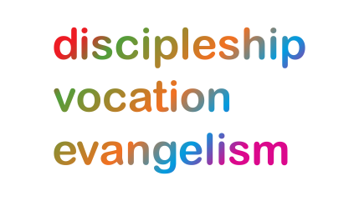Lichfield Diocese Prayer Diary: Issue 39

**This week we have a change of focus as we enter into the blessings of this Christmas season and prepare for the year ahead using sections of the Methodist Covenant prayer.**

**Sunday 27th:** *(John, Apostle and Evangelist)*

The Word was made flesh and lived among us,

and we have seen his glory,

as of the only Son of the Father,

full of grace and truth.

Jesus, light of the world,

**we worship and adore you.**

**Mon 28th:** *(The Holy Innocents)* On this day when we recall the murder of innocent lives,

let us stand before our just and holy God, and remembering the violence and injustice of our world, pray, weep, plead for God’s mercy. *Christe eleison. Kyrie Eleison. Christe Eleison.*

**Tues 29th:** *(Thomas Becket, Archbishop of Canterbury, Martyr, 1170)*

May God the Father keep you in all your days.

May God the Son shield you in all your ways.

May God the Spirit bring you healing and peace.

May God the Holy Trinity drive all darkness from you

and pour upon you blessing and light. **Amen.**

**Wed 30th:**

 *(Revd Chris Thorpe: Blessing for Plough Sunday; Ploughshares and First Fruits 2020)*

**Thur 31st:** *(John Wyclif, Reformer, 1384)* **‘I am no longer my own but yours.**

**Put me to what you will, rank me with whom you will; put me to doing, put me to suffering;**

**let me be employed for you or laid aside for you, exalted for you or brought low for you;’ *(Methodist Covenant Prayer 1)***

**Fri 1st:** *(The Naming and Circumcision of Jesus)* **‘Let me be full, let me be empty, let me have all things, let me have nothing; I freely and wholeheartedly yield all things to your pleasure and disposal.’**

***(Methodist Covenant Prayer 2)***

**Sat 2nd:** (*Basil the Great and Gregory of Nazianzus, Bishops, Teachers of the Faith, 379 and 389, Seraphim, Monk of Sarov, Spiritual Guide, 1833, Vedanayagam Samuel Azariah, Bishop in South India, Evangelist, 1945))*

**‘And now, glorious and blessed God, Father, Son and Holy Spirit, you are mine and I am yours. So be it. And the covenant now made on earth, let it be ratified in heaven. Amen.’ *(MCP 3)***

*For further resources for praying for the worldwide church see the Anglican Cycle of prayer:* [*https://bit.ly/3anQUWG*](https://bit.ly/3anQUWG)