Lichfield Diocese Prayer Diary: Issue 34

This week we once again include several prayers from the resources provided for the month of ‘Prayer for the Nation’.

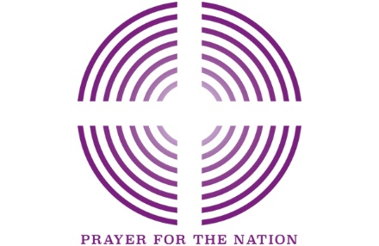
Sunday 22ndNovember: (Cecilia, Martyr at Rome, c.230)
Generous God,
You have provided for your people in every generation. In our faithlessness you remained steadfast. In our obsession with scarcity you provided abundance. In our anxiety you offered us freedom from fear. In our despair you gave us hope.
We receive your gifts, believe your promises and trust you for the future.
May we cease trying to fix the church and join with you in loving your world. May we hear your call to fullness of life and share it with others. May we be shaped by the Good News of Jesus, the light of the world And may we seek your kingdom as People of Hope. Amen. (Shaping for Mission Prayer)

Mon 23rd: (Clement, Bishop of Rome, Martyr, c.100) Schools and colleges, children and young people We pray for all those involved in the shaping of young lives. We give God thanks for the sacrifice and commitment of teachers and all those involved in serving children and young people in education. We pray that all might be nurtured and cared for and that every needful resource would be made available – that all lives can flourish even in these difficult times and that no-one would be overlooked.

Tues 24th: Lord Jesus Christ, in these dark and difficult days, we turn our hearts to you. In ages past, you have delivered our nation from disaster. Do it again, we pray. Give wisdom beyond human wisdom to our leaders, Give strength beyond human strength to the NHS and all our frontline workers. Give comfort beyond human comfort to the elderly and all who grieve. Lord Jesus Christ, in these dark and difficult days, turn your face towards us, have mercy upon us, and heal our land, we pray.

Wed 25th: (Catherine of Alexandria, Martyr, 4th century; Isaac Watts, Hymn Writer, 1748) Businesses, the workplace and economic wellbeing: In this time of great challenge, we pray for the economic wellbeing of the country. We remember before God those who face great uncertainty in their work. We lift before God those who have lost their jobs and face an uncertain and difficult future. We pray for a renewed commitment to our common life together.

Thur 26th: A Family Prayer: Loving God, you know us and all that we are facing. We thank you that we can come to you as we are – with all our fears and concerns, our difficulties and challenges. Please draw close to each of us and those we remember before you now. Bring to us your peace and comfort. And fill us with your Spirit that we may be bearers of your grace and hope to others. As a country protect us, encourage us and keep us. In the name of your Son Jesus, we pray. Amen.

Fri 27th: We give thanks for the development of Covid-19 vaccines; we pray for those continuing to research and trial these; that these vaccines may be made available to the world’s poorest people; we pray for the Anglican Communion Health and Community Network and the Anglican Communion Science Commission, working together on Anglican responses to the Covid-19 pandemic.
Sat 28th: For the Christian community: We are not people of fear: we are people of courage. We are not people who protect our own safety: we are people who protect our neighbours’ safety. We are not people of greed: we are people of generosity. We are your people God, giving and loving, wherever we are, whatever it costs, for as long as it takes, wherever you call us. (Barbara Glasson, President of the Methodist Conference)

For further resources for praying for the worldwide church see the Anglican Cycle of prayer: https://bit.ly/3anQUWG

