Lichfield Diocese Prayer Diary: Issue 33

This week we depart from our usual cycle of prayer to join with the month of Prayer for the Nation.
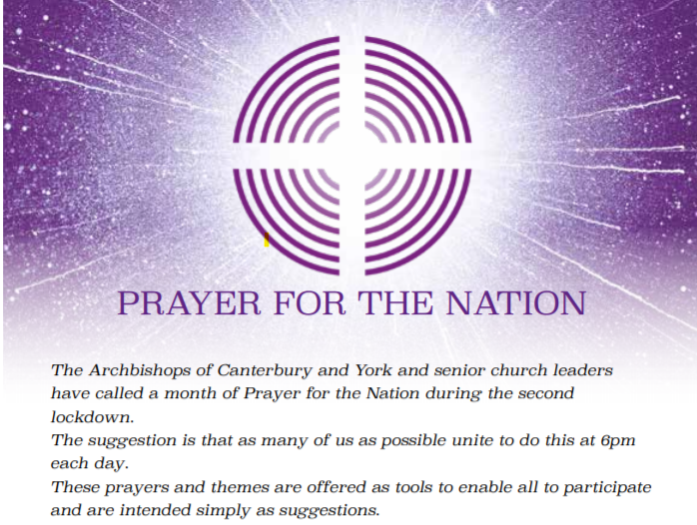
Sunday 15thNovember: Family, friends and loved ones We lift to God those we hold in our hearts – praying for their health, their well-being and their sense of hope. We pray that even when loved ones cannot physically be together they would not feel apart. We ask for God’s help in our communicating, our connecting and our caring.

Mon 16th: Schools and colleges, children and young people We pray for all those involved in the shaping of young lives. We give God thanks for the sacrifice and commitment of teachers and all those involved in serving children and young people in education. We pray that all might be nurtured and cared for and that every needful resource would be made available – that all lives can flourish even in these difficult times and that no-one would be overlooked.

Tues 17th: Elderly, isolated and vulnerable We echo God’s commitment to those most at risk of this virus by praying today for those who are particularly vulnerable and isolated: praying for their deliverance, protection and comfort. We hold before God those who care for them – that they would be strengthened and encouraged in this work.

Wed 18th: Businesses, the workplace and economic wellbeing In this time of great challenge, we pray for the economic wellbeing of the country. We remember before God those who face great uncertainty in their work. We lift before God those who have lost their jobs and face an uncertain and difficult future. We pray for a renewed commitment to our common life together.

Thur 19th: (Hilda, Abbess of Whitby, 680; Mechtild, Béguine of Magdeburg, Mystic, 1280) The NHS and other key workers Our God is the great healer – and the agent used more than any other is the NHS. Today we voice our gratitude for those who serve this country in the National Health Service and pray for that God would prosper the work of their hands – that they would all be encouraged in their continued work of sacrifice and care amongst us. We give particular thanks for progress with a vaccine against Covid-19 and pray for its successful implementation.

Fri 20th: National and Local government We pray for those who are in positions of authority with responsibility for decision making at national and local level at this difficult time. We ask that God would give great wisdom, deep commitment to all and right judgment.

Sat 21st: All who are grieving, and all suffering with physical and mental ill-health ‘Lord the one you love is ill….’ John 11 v 3 We bring to God all those who suffer in body, mind, spirit or with grief. We ask that in God’s great loving kindness they might know God’s sustaining presence amidst their pain. We pray for those who are stretched beyond their own capacity to cope and remain hopeful. Lord, look in mercy on the most vulnerable throughout the world.

For further resources for praying for the worldwide church see the Anglican Cycle of prayer: https://bit.ly/3anQUWG

