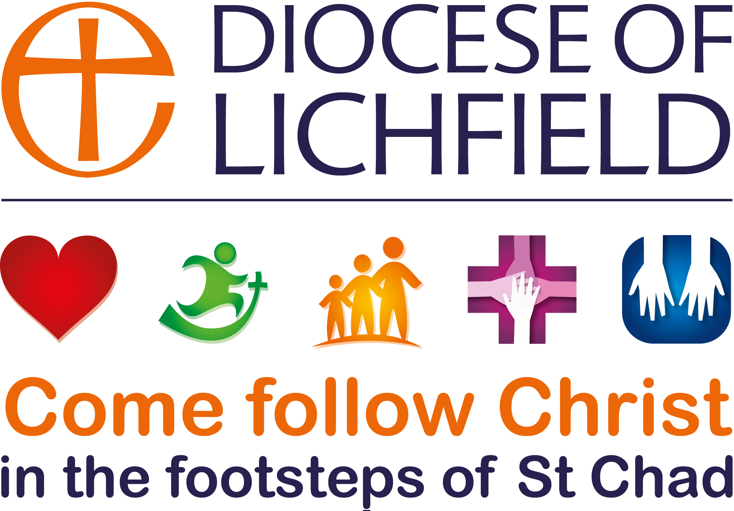

PARISH DECLARATION FORM
Please complete the form and return it to your Archdeacon.
The information provided will assist us in confirming the updates you provide electronically for the database via the Place Audit and contacting various church officers about important matters.
DEANERY:
CHURCH & PARISH:

CHURCH TREASURER AND CONTACT DETAILS
Name
Address
Tel: Email:
Please indicate how you have submitted your year-end accounts:
Electronically Paper Copy sent to S Mary’s House Not complete

SAFEGUARDING OFFICER AND CONTACT DETAILS
Name
Address
Tel: Email:
Please indicate the date of the PCC meeting when you most recently presented and discussed your parish safeguarding policy: Date of Meeting

PCC SECRETARY AND CONTACT DETAILS
Name
Address
Tel: Email:

PARISH ADMINISTRATOR AND OFFICIAL ADDRESS & CONTACTS FOR CORRESPONDENCE
Name
Address
Tel: Email:
Parish website address:

