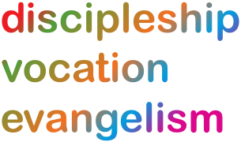
Lichfield Diocese Prayer Diary: Issue 17

During these weeks the prayer diary reflects the challenges of facing Coronavirus with our sisters and brothers across the world; the call to be a people of hope.

Sunday 26th July: Anne and Joachim, Parents of the Blessed Virgin Mary CHURCHES: Pray for all our churches seeking to open their doors for worship and prayer whilst still providing support for those who are not able to attend church. Pray for our Deaneries throughout the Diocese, for our Rural / Area Deans and their Assistants, for all representatives from parishes, that our Deaneries may provide mutual support and be a means of fulfilling our call to mission and evangelism.
Mon 27th: Brooke Foss Westcott, Bishop of Durham, Teacher of the Faith, 1901 COMMUNITIES: For the various courses being run by Transforming Communities Together offering resources for those made more vulnerable through the Pandemic. Pray for the COVID Cash Course which is available to individuals and community organisations to help them deliver vital information on Universal Credit, Mortgage and credit changes remotely to individuals in their community.

Tues 28th: SCHOOLS: Father God you are the God of beginnings and endings – you are alpha and omega,
As we come to the end of an extraordinary school year and look forward to the holidays beginning
We pray for all our school families – both the pupils and the staff.
We pray for safety, and blessings through the summer months.
We think particularly of those who will struggle to put food on the table at this time.
We pray against the injustice and poverty that still impact our families.
May you grant rest to all are weary and your peace to all.

Wed 29th: Mary, Martha and Lazarus, Companions of Our Lord PRISONS: Father God, we pray that you would bless, comfort and strengthen prisoners and prison staff, their families and friends. We are thankful for the continuing engagement between prisoners and their families and with staff and for the relationships that are built and the support that is offered. We pray for those who work within the Justice System and the Prison and Probation service, who are all continuing this vital work either at home, or in their workplaces. We pray particularly for those residing and working at HMP Drake Hall, HMP Stafford, HMP Stoke Heath, HMP Swinfen Hall and HMP Werrington.

Thur 30th: William Wilberforce, Social Reformer Olaudah Equiano and Thomas Clarkson Anti-Slavery Campaigners, 1833, 1797 and 1846 AROUND THE WORLD: World Day against Trafficking in Persons: Remembering the greater impact of the Covid-19 Pandemic on the most vulnerable, we pray for churches in the Diocese of Durgapur who are at the forefront of the Church of North India’s fight against human trafficking. May they be safe havens for all who are at risk. For the women’s self-help groups the CNI works with to help women and girls who are at risk of being trafficked. As we give thanks for the work of the CNI’s Anti-Human Trafficking Programme, let us also pray for similar programmes to be launched in other parts of the world where such initiatives are needed.
Fri 31st: Ignatius of Loyola, Founder of the Society of Jesus, 1556 HEALTHCARE: For the spiritual and emotional well-being of all working in healthcare services at the present time, for those who are themselves ill with Coronavirus or struggling with its longer term complications; for all Chaplaincy Teams offering pastoral care and support to patients and staff in our hospitals and for all programmes of counselling being offered in response to the trauma and loss caused by this pandemic.
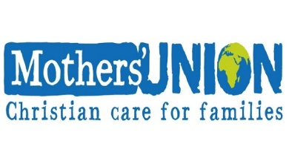
Sat 1st: AROUND THE WORLD: Give thanks for the Mother's Union made up of 4 million members active in 84 countries throughout the Anglican Communion. For Adie Harris in her role as our Interim Diocesan President until the end of the triennium, December 2021 and for all trustees; for the web-based ‘Communities of Interest’ initiative and from the Wave of Prayer for the work of the Mother’s Union in Boga in DR Congo; Manicaland in Zimbabwe; Tanga in Tanzania; Ogoni in Nigeria; Carlisle in England and Melbourne in Australia and for our link Diocese of Matlosane.

For further resources for praying for the world wide church see the Anglican Cycle of prayer: https://bit.ly/3anQUWG

