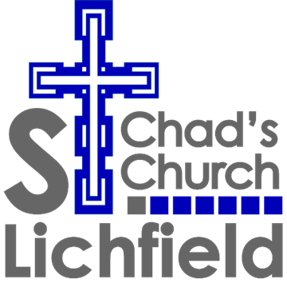
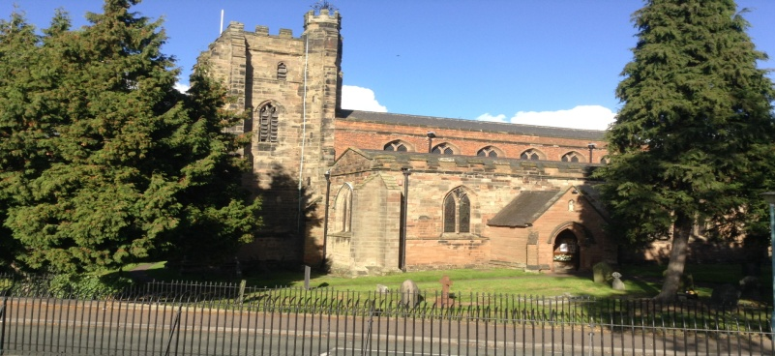

St Chad’s Parish, the place where Chad lived and prayed during his foundational ministry as Bishop of Lichfield, seeks an Administrator to support the mission and outreach of the church.
This part-time post is based at the St Chad’s Parish Office in Well Cottage next to St Chad’s Church, and involves working closely with the Rector and Church officers.
If you share the key St Chad’s values of Inclusivity and Welcome; Generosity and Hospitality; Prayer and Pastoral Care; Evangelism and Healing, the post may be for you.
If you wish to apply for the post please send a CV and covering letter addressing the requirements of the job description and person specification and including contact details for two people who are able to provide a reference. One of these must be a recent work reference.
To obtain a copy of the information, or to arrange an informal conversation about the post, please contact the Rector on 01543 262254 or revrod.stchad@gmail.com
The closing date is Monday 7th November.
Please send applications, either electronically or by hard copy, to:
St Chad’s Parish Office, 42 St Chad’s Road, Lichfield, WS13 7ND 01543 416595 office@saintchads.org.uk

St Chad’s Church - seeking to live the Christian life in community with simplicity, humility and boldness

