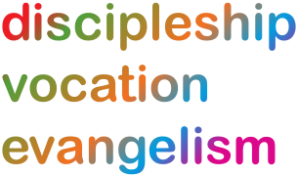
Lichfield Diocese Prayer Diary: Issue 44

Our prayers take forwards the ‘Shaping for Mission’ Deanery focus. As People of Hope we remain mindful too of the implications of Covid-19, both locally and globally.

Sunday 31st January: (John Bosco, Priest, Founder of the Salesian Teaching Order, 1888) We pray for the West Bromwich Deanery; Area Dean: Fr Ron Farrell; for ministry within an urban context at the heart of the Black Country; for the clergy and faithful of the 10 Churches and the ministry of the 7 Parishes and 7 Benefices; for the 3 Church Schools and 4 Chaplaincies and several Fresh Expressions; for insight to discern ways in which the Deanery can work effectively together across different locations and contexts; for eternal rest for those who have died from and with Covid-19.

Mon 1st February: (Brigid, Abbess of Kildare, c.525) Shaping for Mission: for the West Bromwich Deanery, for their Shaping for Mission Facilitator Steve Hollinghurst; for the work of the Shaping for Mission Team; for growth in faith and in numbers as they seek to rekindle the life of their church communities; for greater concern for the communities they serve.
‘May we be shaped by the Good News of Jesus, the light of the world
And may we seek your kingdom as People of Hope. Amen’.

Tues 2nd: (The Presentation of Christ in the Temple -Candlemas) Child of our longing, hope of ancient days,
comfort for the lowly, challenge for the proud, you come to challenge our established structures of power, you come for the falling and rising of many. Come now and open our hearts to your presence in our midst. Amen. (Revd Preb Chris Thorpe, Candlemas, Dreamers and Stargazers; 2017)

Wed 3rd: (Anskar, Archbishop of Hamburg, Missionary in Denmark and Sweden, 865) For the Black Country Healthcare NHS Foundation Trust, praying particularly for the Spiritual Care Team and for Revd Emma Louis in her role as Spiritual Care Lead and Head of Diversity & Spirituality, as the Team responds to the great challenges whilst nourishing hope; pray for the mental health of the staff and for good use of the resources which they have created for both staff and patients to work through and to nurture hope and self-compassion; for Emma’s teaching of mindfulness on-line.

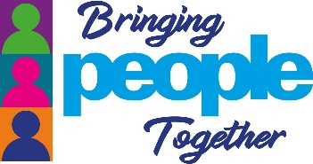
Thur 4th: (Gilbert of Sempringham, Founder of the Gilbertine Order, 1189) Transforming Communities Together: as Lockdown 3 has highlighted the need for new ways to build community and tackle isolation, pray for the Bringing People Together initiative; for people to find this network designed as a safe way for Churches and others to ‘connect people to others from the comfort of their own home’. Pray for the webinar on 12th February and for Su Parker, the Bringing People Together coordinator

Fri 5th Prisons: for all staff, who are working very hard in difficult circumstances which are both exhausting and challenging for them; for Chaplaincy in seeking to provide the best care possible for staff and prisoners; for prisoners – particularly those who have suffered recent bereavements, who have family members who are very (some terminally) ill and those who are due for release, who are going into a world that looks very different to the one that they left.

Sat 6th: (The Martyrs of Japan, 1597) For the witness and mission of the Nippon Sei Ko Kai (The Anglican Communion in Japan); for the Primate & Bishop of Kyushu, The Most Revd Luke Kenichi Muto; for the witness of the Christian church today, to fulfil God’s calling to peace and reconciliation.

