Transforming Church and Community
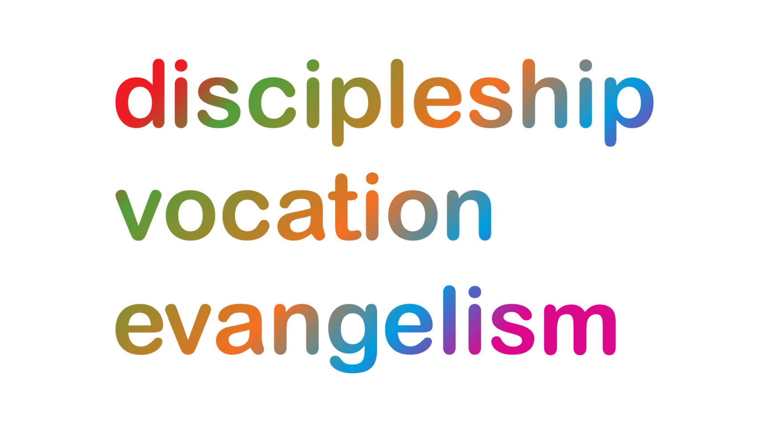
Transforming Church and Community
Discipleship: - The Transforming Church and Community team celebrate the discipleship of churches when, developing as communities in transformation, they are part of the transformation of their communities.
Vocation: - When churches are called to extend their ministry, the Transforming Church and Community team offers support and encouragement to maximise the efficacy of the assets at their disposal.
Evangelism: – Inspired by the good news of Christian hope, the Transforming Church and Community team works, in partnership with churches and others, both for justice in the here and now, and for justice across the globe and the generations
Environment
Discipleship: – We are encouraging and equipping churches and church leaders to engage thoughtfully and theologically with environmental issues, particularly through the season of Creationtide and the EcoChurch awards scheme.
Vocation: – We are developing a support network of ‘Environmental Champions’ for those with a particular vocation to creation care, and through the EcoChurch scheme we are helping all Churches and Christians to engage with creation care as part of their vocation.
Evangelism: – Increasing environmental awareness provides new ways for Christians to engage creatively with those outside the Church, showing love to God and neighbour, and we are supporting and promoting opportunities to do this – such as the Climate Action Day.
Churchyards
Discipleship: - Churchyards are peaceful places for prayer, remembrance and reflection where we can grow closer to God as we think about others who matter to us.

Vocation: - Across the diocese, thousands of parishioners respond to the call to look after and maintain God’s acre in service of God’s creation and the wider community.

Evangelism: - As we enable people to encounter God in creation in these hallowed grounds, so people can come to know the Lord of life who is Lord over death.
Wellbeing of the Ministers of the Gospel
Discipleship: - We promote and seek to foster the wellbeing of our Clergy, LDBF employees, Readers and other licensed lay ministers as we continue to learn and grow in discipleship ourselves in order more faithfully to serve others
Vocation: - Facilitating one-to-one and group work (education and counselling) helps to promote life-long and whole-hearted vocational exploration ensuring ministers are growing psychologically and spiritually into a healthy maturity in Christ
Evangelism: – The ‘abundant life’ promised by Jesus can be lived by the ministers of the gospel in good times and in bad and thus is modelled as good news for those we seek to love and serve
Ministry Development Review
Discipleship: – the MDR process enables church leaders to reflect and review where they are in their ministry, to anticipate the changing demands of the role and identify appropriate objectives and areas for ongoing training and development as well as support.
Vocation: –signposting opportunities for training and development at all stages of ministry, offering resources from within the Diocese, West Midlands CMD courses and external training providers.
Evangelism: –equipping and encouraging Ministers to resource and enable congregations so that, together, they may find ways of demonstrating the love of God and neighbour in their contexts.

Workplace Chaplaincy
Discipleship : - We encourage Christians to see their working lives as a place where their discipleship is expressed and may grow.
Vocation: - We offer training in chaplaincy skills, introductions to businesses and ongoing connection and support for voluntary chaplains.
Evangelism: - We support the witness of Christians on their Front Line, so that those in the workplace can see the relevance of faith to the everyday challenges of life.

Enabling Church
Discipleship: – We encourage and equip churches to reflect in worship and discipleship what it means for everyone to be “limited” human beings; all made in the image of God, known and called to know and follow Christ exactly as we.
Vocation: – We share stories and training to awaken the church to the gifts that disabled people bring to the church. We help churches to identify barriers & ensure that everyone is enabled to flourish in their gifts.
Evangelism: – We work to help churches remove barriers which prevent disabled people from being a full and active part of the church family and experience the ministry of disabled people as a prophetic witness and gift to the Body.
Mental Health
Discipleship: – We encourage congregations to be open and honest about Mental Health by including the topic in regular sermons, special ‘awareness days’ and by being a support when complex pastoral situations might arise.
Vocation: – Through training, we are equipping leaders to be Mental Health First Aiders, taking their experience and knowledge into their own areas of ministry to better serve their communities. We are removing barriers so all might know they are called by God, regardless of background or circumstances.
Evangelism: – We encourage churches to be pioneers in breaking taboos and being truly open to the broken hearted and those who have often been shunned and misunderstood by society. We work to ensure churches are safe and accepting places for all.
Dementia Friendly Church
Discipleship: – We help Christians work through the impact of dementia on their lives and the lives of those whom they know, to come to a deeper understanding of God’s presence in all aspects of our life.
Vocation: – We support dementia friendly churches called to be at the heart of dementia friendly communities.
Evangelism: –.In the challenging context of dementia, we are people of hope holding on to the importance of each person knowing each moment that they are loved by God.
Development Work
Discipleship: - We are commanded by Jesus to ‘love one another’ as he loved us. Our team provide one on one or group support to enable people to fulfil this.
Vocation: - Our team provide a variety of ways for people to use their gifts and skills in acts of service and enable them to weigh and test their calling.
Evangelism: – Our team have the privilege of catalysing, developing and observing the good news of the kingdom of God growing in parishes across the Diocese and sharing this with others.

Social and financial inclusion
Discipleship: - Through the examples of Jesus, many seek to continue to remember the poor in our daily lives. We provide practical ways, advice and support for people to do this in ways that empower others.
Vocation: - Our range of events and training sessions enable people to add to their gifts and talents and give opportunities to build confidence and competence as they test their calling.
Evangelism: – Jesus called us to bring ‘good news’ to the poor. He did this incarnationally, working alongside as a servant. Through our partnerships, we provide a range of ways for people to fulfil this.

Community Cohesion
Discipleship: - We promote discipleship by empowering people to live out in a daily basis Jesus’ calling to love their neighbour, irrespective of what race, creed or colour they are from. We walk alongside people and groups, providing a sounding board, practical advice and support.
Vocation: - We provide practical support and encouragement, as well as funding to help people fulfil their call to unconditionally love and serve those of different religions, races and cultures within our parishes
Evangelism: – In many of the communities we work in, hope is in short supply. Our diverse team are committed to bringing hope into people and communities, to enable them to have the ‘life in all its fullness’ that Jesus came to give.

